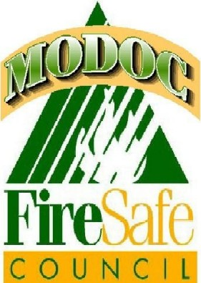
Modoc Fire Safe Council
501(c)3 Not for Profit Organization
114 N. East St., Alturas, CA 96101
Mailing Address: P.O. Box 1448
Alturas, CA 96101
(530) 233-5516

Landowner Assistance Program
Request Form

Name: __________________________________________________
Address/Location of Property: ______________________________
City: _______________________________ Zip: _________________
Assessor’s Parcel Number: ______________________________
Mailing Address: ___________________________________________
Phone Number: ___________________________________________

Are there any special precautions to take on the property? ________________________________________________________________________________________________________________________________________________

I, _________________________, the undersigned, am the rightful owner of the property stated above. I am a senior citizen (60 and above) ____/ disabled____ / U.S. Veteran ______/ low-income resident of Modoc County living in a rural area. I am physically unable to perform the activities necessary to create a 100 ft. defensible space around my home. If you have checked the low-income eligibility line, please fill out the Low-Income Eligibility form attached.

I understand that the goal of Modoc Fire Safe Council (hereinafter referred to as MFSC), together with its volunteer partners, in this program is to assist the homeowner in creating a 100 ft. (or to the property line) defensible space around their home to decrease damage to property in case of wildfire. I understand that this program does not guarantee that my home will survive a wildfire.

By signing below, I also agree to the following terms and conditions:

- I agree to admit the Modoc Fire Safe Council’s private contractor and its designated volunteer partners onto my property.
- I agree that I, together with members of my family and friends may not assist and must stay a safe distance from the treatment area, until notified by the contractor (or designated volunteer partner) that it is safe to do so.
- I understand that the MFSC contractor has final authority in determining where slash piles should be placed around the property for safety purposes, in preparation for the volunteer partners’ piling activities and the chipping program.
- I understand that it may take several days or weeks before chipping of the slash piles can be done.
- I understand that the MFSC is not obligated to perform this service and the MFSC is not liable for its failure to perform this service.

Signature __________________________________ Date ____________________

Modoc Fire Safe Council
Land Owner Assistance Low Income Guidelines

Please circle which household size and monthly income amount reflects your situation
Household Size | Not to Exceed Monthly Income | I certify that I do qualify for this program based on my house hold size and monthly income:
1 | $0 – $1,255.00 | Print:  Signature:
2 | $0- $1,703.33 | Print:  Signature:
3 | $0 - $2,151.67 | Print:  Signature:
4 | $0 - $2,600.00 | Print:  Signature:
5 | $0 - $3,048.33 | Print:  Signature:
6 | $0 - $3,496.67 | Print:  Signature
7 | $0 - $3,945.00 | Print:  Signature:

*This income block was built from the 2025 HEAP and FAST TRACK Base Benefit Amount
Household’s Monthly Income Guidelines & Poverty Group II

THIS PAGE AND INFORMATION GATHERED FROM IT ARE STRICTLY CONFIDENITAL AND WILL NOT BE SHARED OR PROVIDED BY ANYONE ASSOCIATED WITH THE MODOC FIRE SAFE COUNCIL

